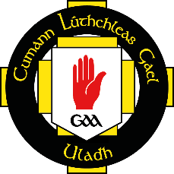
Cumann Lúthchleas Gael
Comhairle Uladh

2019 FinTrU Ulster GAA Football Inter-Firms
Application Form
B CEAD AGUS DAINGNIÚ (Permission and Ratification)

The above application has been approved by Comhairle Uladh and is hereby acknowledged.

Sínithe ……………………………………………………………… (Comhairle Uladh)

Data ……………………………………………..
A IARRTAS (Application) - to be completed by company

Team Name ……………………………………………………… Colours …………………………………………………………

Competition: Ladies □ Men Senior □ Men Junior □
7-a-side 15-a-side 9-a-side
Sat 12th October Sat 19th October Sat 26th October
Entry Fee: €50 / £50 €300 / £285 €300 / £285

(Entry Fee for Men competitions includes affiliation to GAA Injury Benefit Fund at €200 per team)
(There is no Player Injury cover for the Ladies competition, teams should arrange their own cover)
For BACS details for electronic payment contact niall.muldoon.ulster@gaa.ie

Contact Info
Name ………………………………………………………………
Address …………………………………………………………….
………………………………………………………………
………………………………………………………………
Phone No ………………………………………………………….
Active Email ……………………………………………………...
Sínithe ……………………………………………………………… Dáta ………………………………………

Application forms must be returned to Comhairle Uladh no later than 3:00pm on Monday 30 September 2019
to Niall Muldoon, Ulster GAA, 8-10 Market Street, Armagh, BT61 7BX or niall.muldoon.ulster@gaa.ie

