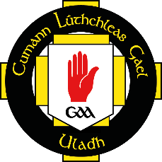
COMHAIRLE ULADH CLG
OFFICIAL PLAYER REGISTRATION FORM

COMPANY NAME
COMPETITION / COMÓRTAS
DATE/DÁTA

 | NAME | CLUB & COUNTY | EMPLOYEE ID
 | (FIRST & SURNAME) | (IF APPLICABLE) | (IF APPLICABLE)

DECLARATION
I can confirm that the above names are contracted employees of the company, and are not a sub-contractor or a one day representative. Only players named above, who are full-time employees of the company, are eligible for cover via the GAA’s Injury Benefit Fund.

COMPANY MANAGER/DIRECTOR
SIGNATURE/SÍNIÚ
DATE/DÁTA

